Creating an event triggered business process leveraging multiple managed services from AWS

1. Create EC2 instance which receives the notification when an invoice is placed in S3 with Python

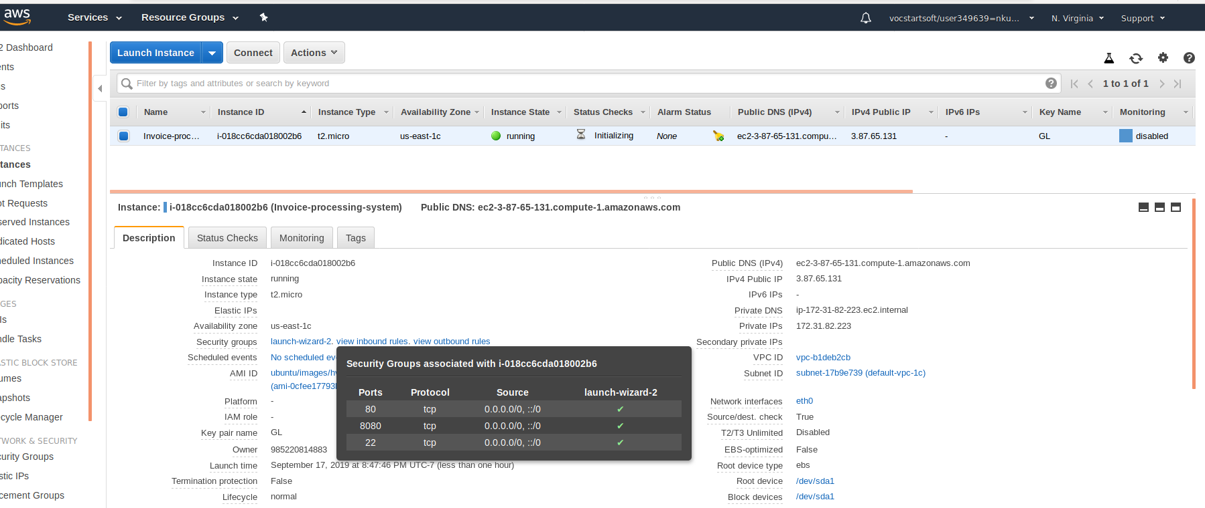

1. Python-pip installation

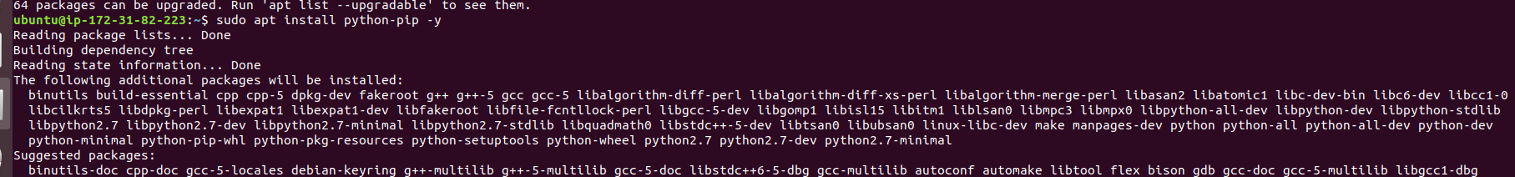

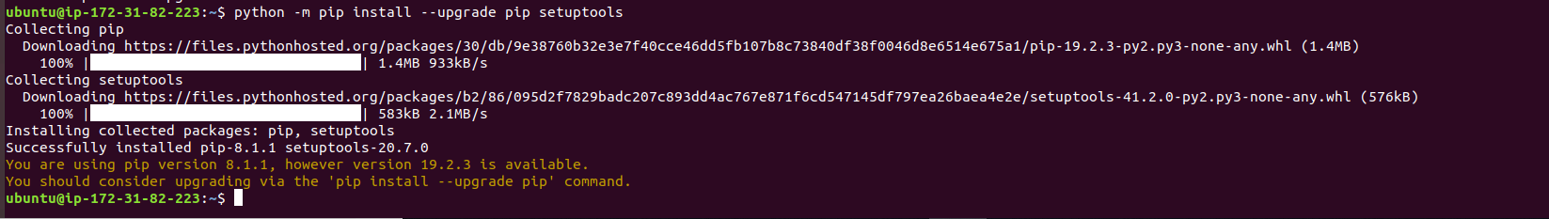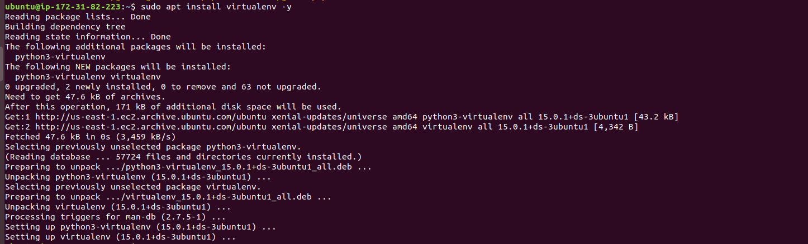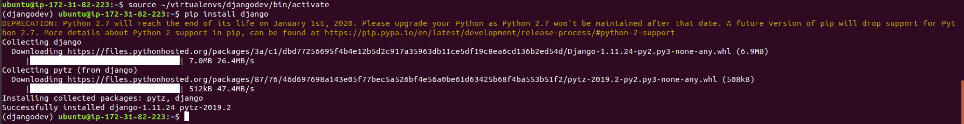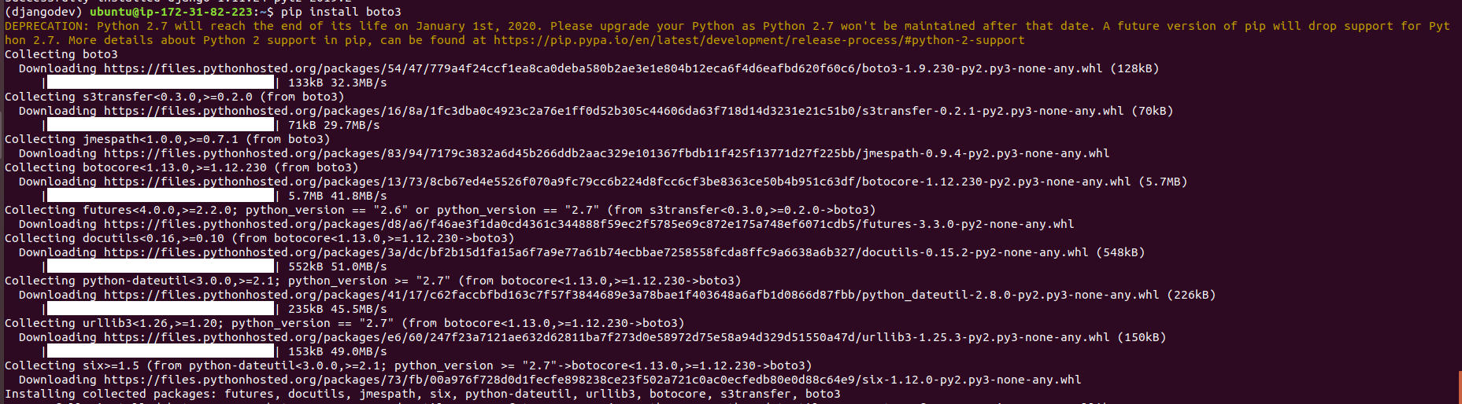

1. Copy .pem file to /opt



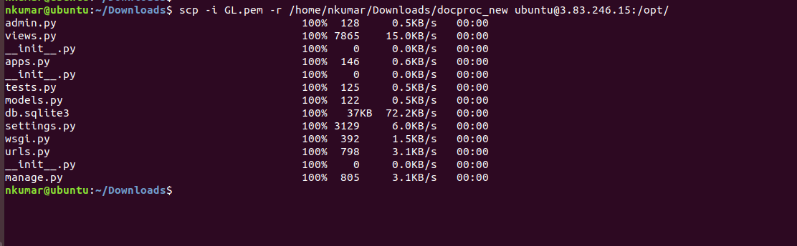

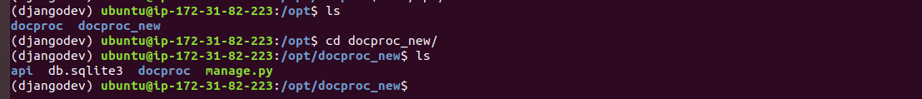

1. Running program on 8080

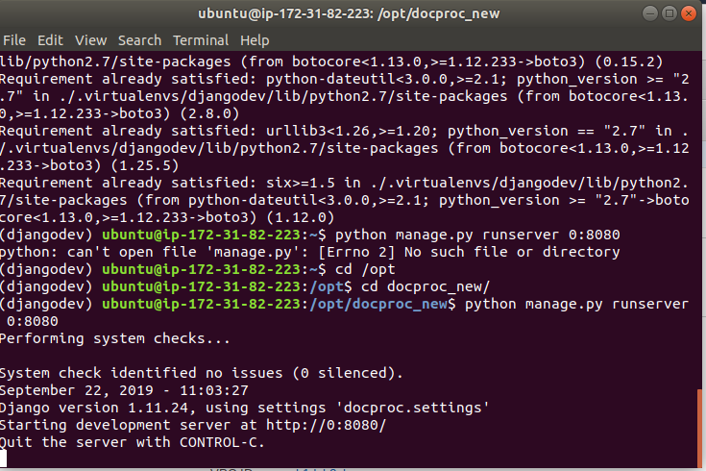

1. Verifying the endpoint access

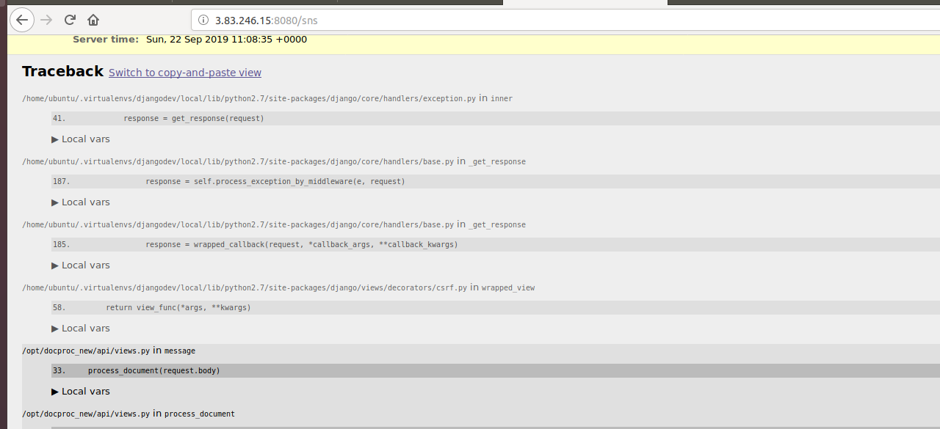

1. Creating Source bucket in S3

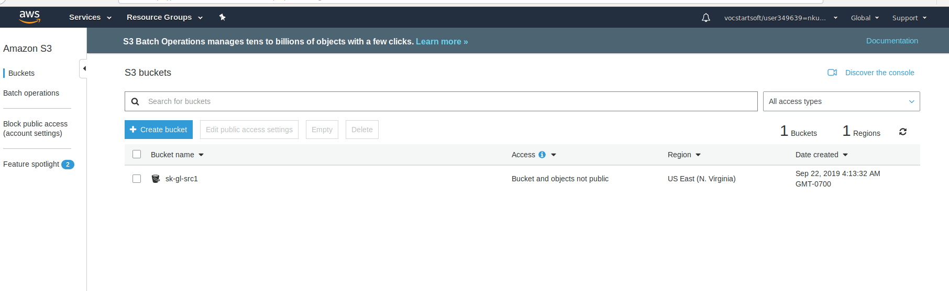

1. Create SNS

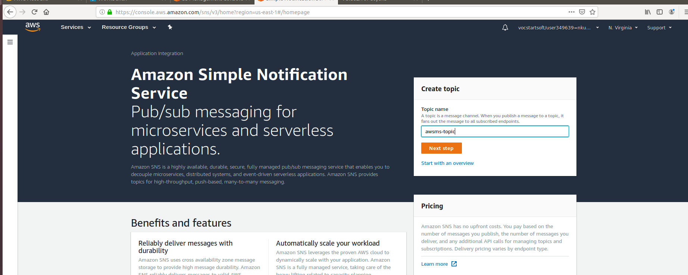

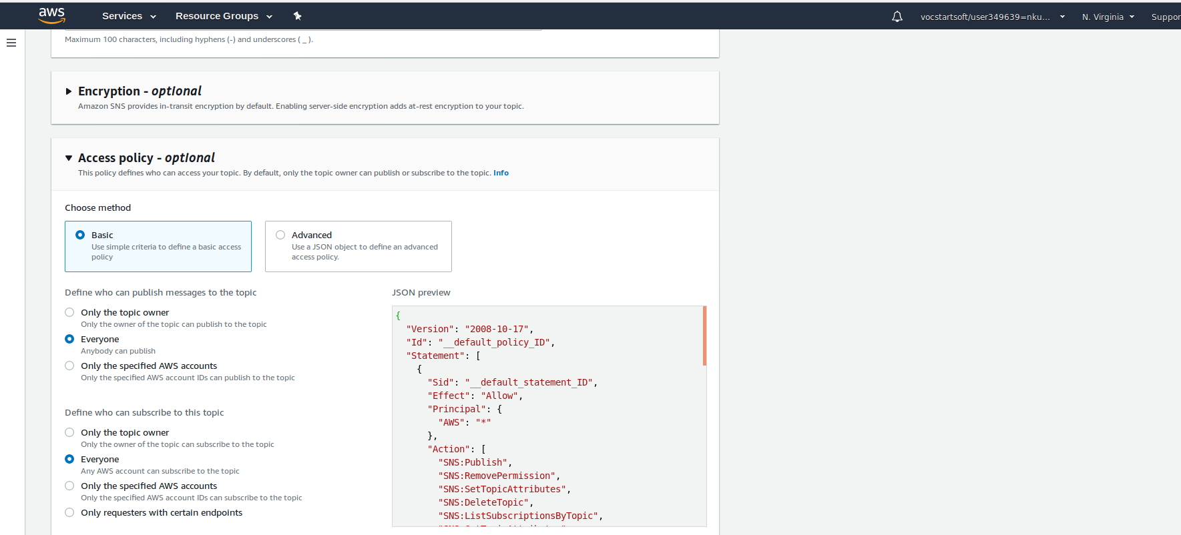

1. Generate the events in S3 bucket

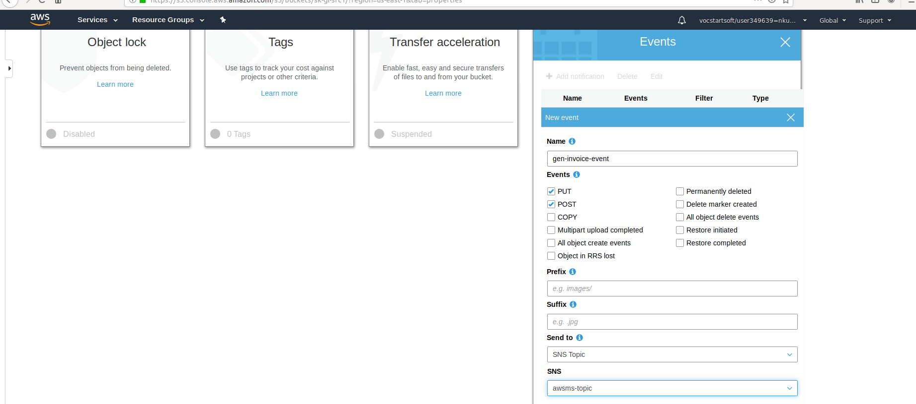

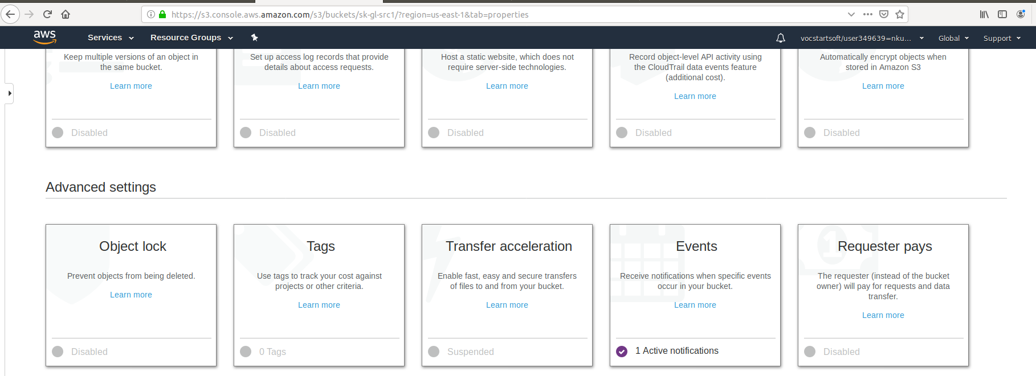

1. Create the subscription in SNS

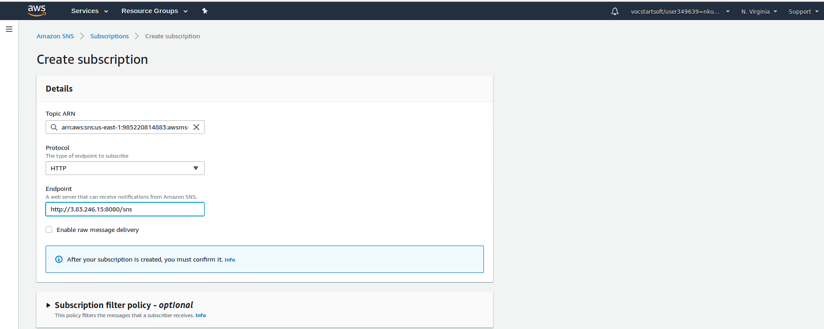

1. SNS Subscribe confirmation

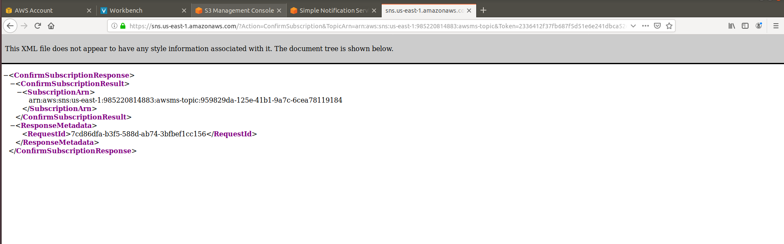

1. Verifying subscription under SNS topic

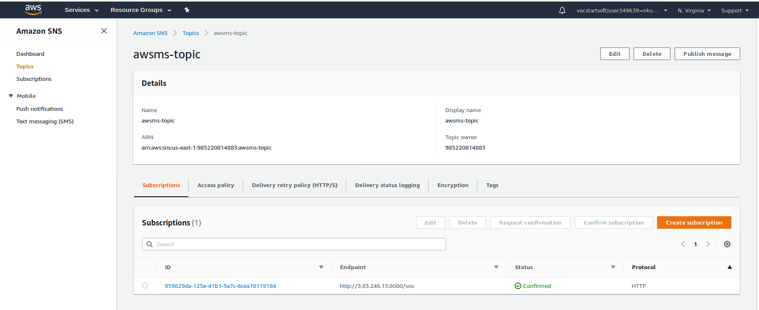

1. Create the destination confirmation

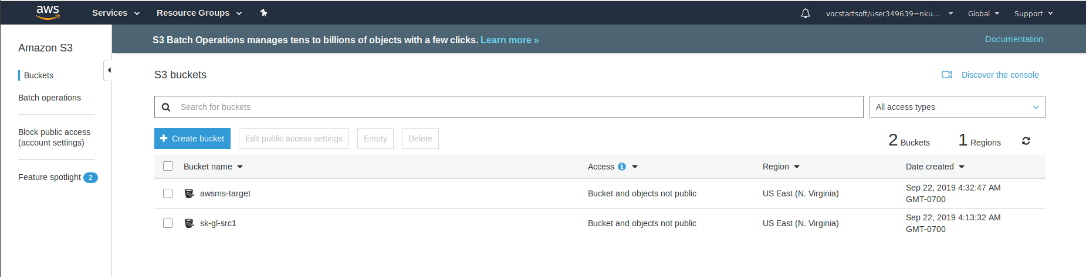

1. Create role to access Dynamo-DB and S3

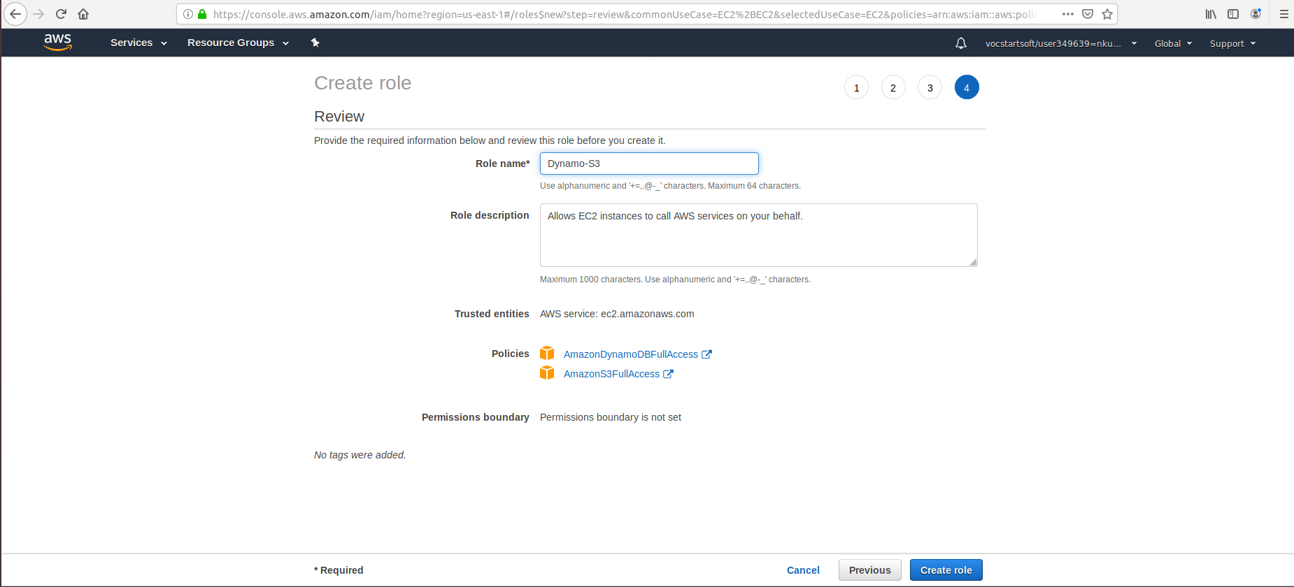

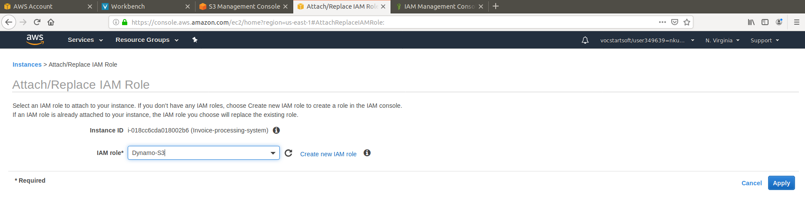

1. Upload invoice to Source bucket

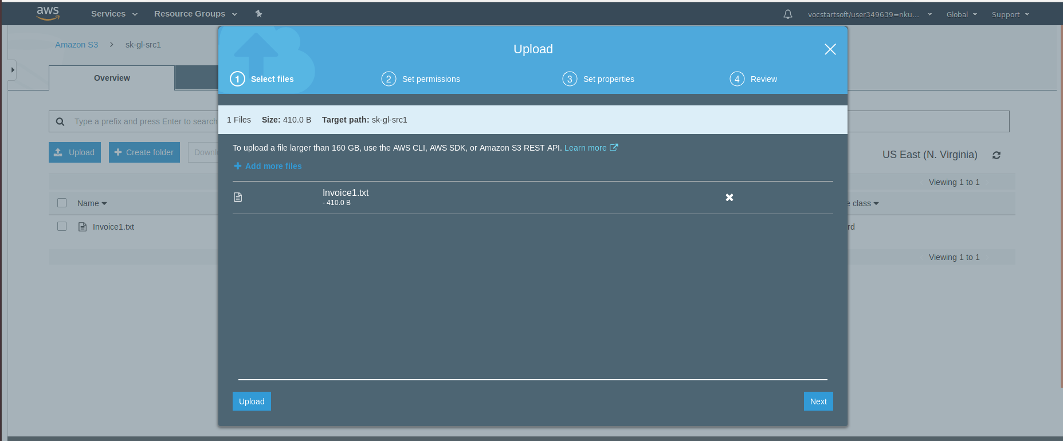

1. Invoice in Target Bucket

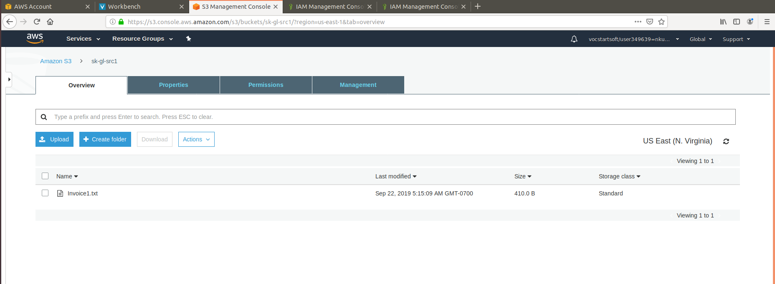

1. Invoice table inserted in Dynamo-DB Table

